Adding new Test plan 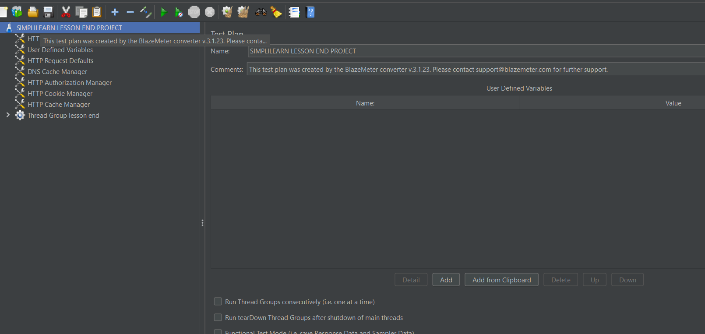

* Adding Theard Group to the test plan by Right click on the test plan then click on add ,then click on thread(users) and click on the thread group .

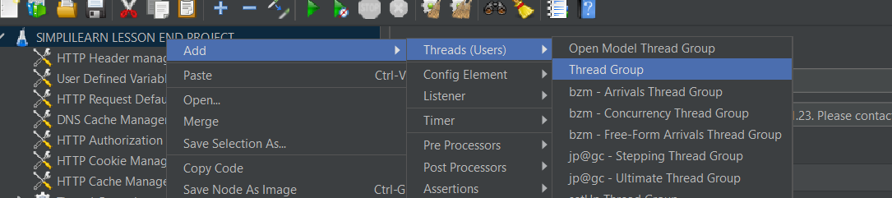

* Recording the script through the Blaze meter ,then the download script are saved in the download list ,

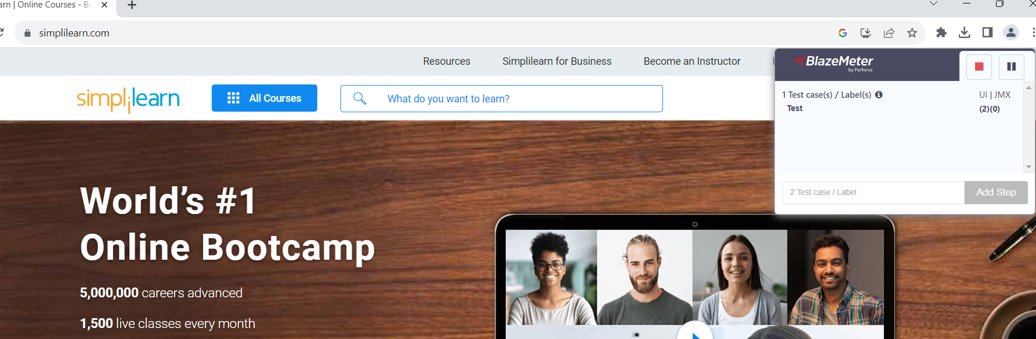

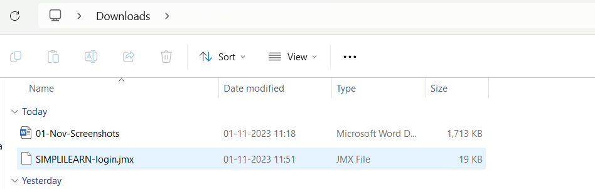

* Recorded script is added to jmeter

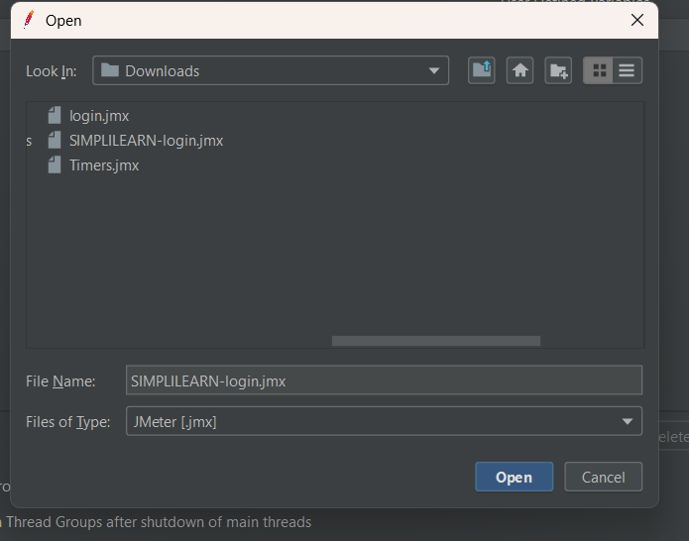

Then the recorded script -

Samples are placed in sample controller

* Right click on the thread group and click on the add then click on the logic controller then click on the simple controller .
* In this project I am creating three simple controller for best understanding purpose .

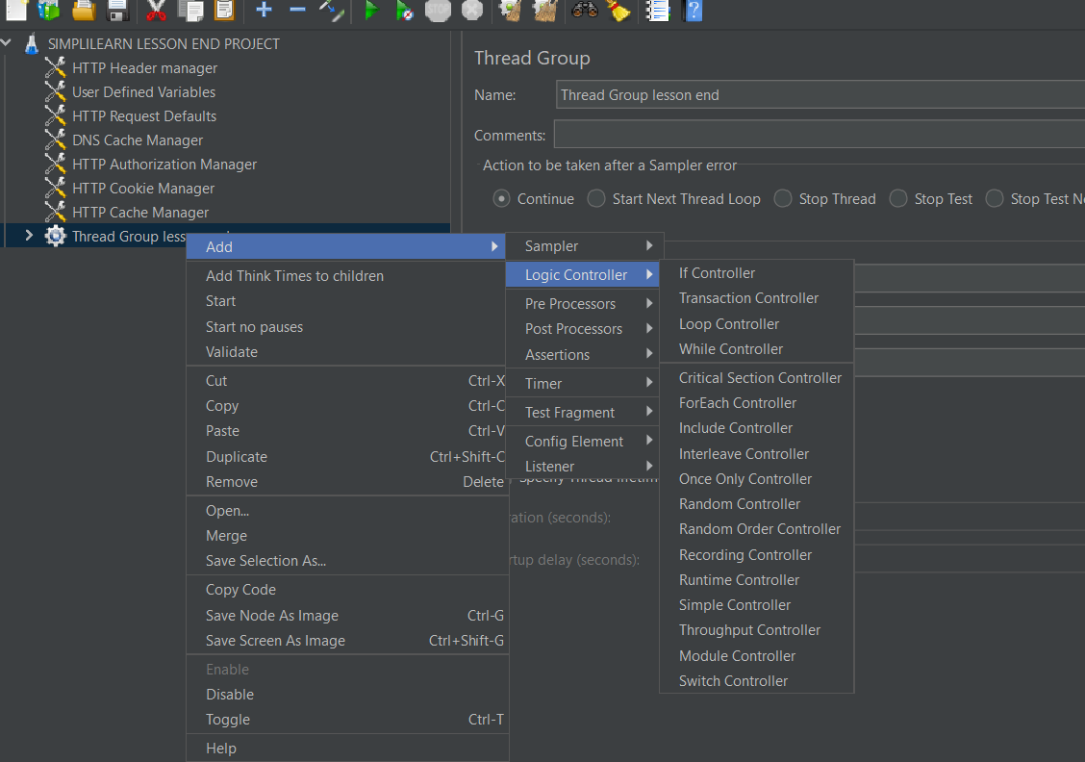

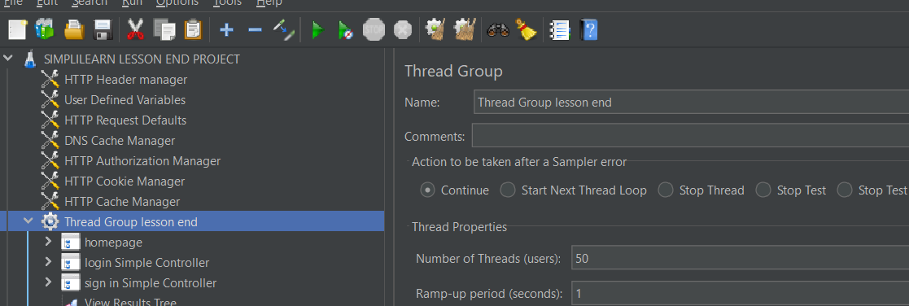

Adding response assertion to homepage simple controller

By right click on the simple controller ,click on add ,then click on assertions ,and click on Response Assertion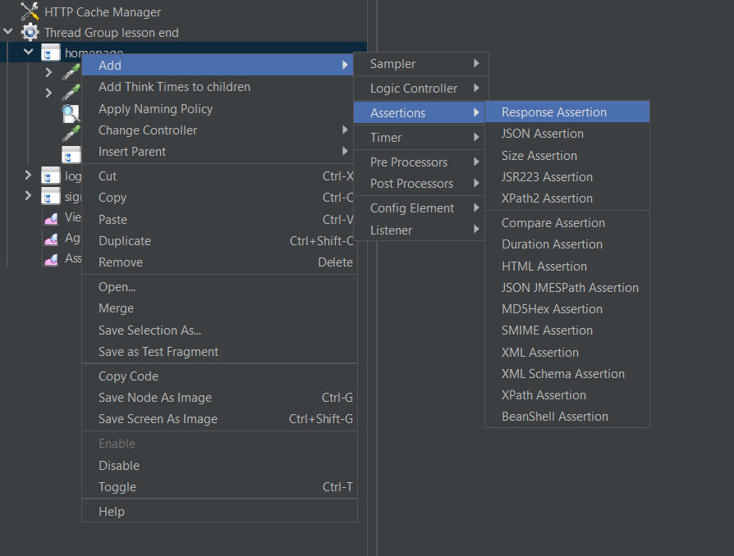

Adding 200 in pattern to test in response assertion by click add button in response assertion.

That means it will check the respond message to request message ,if both are 200 then the assertion is true then the test sample is pass ,otherwise it will fail.

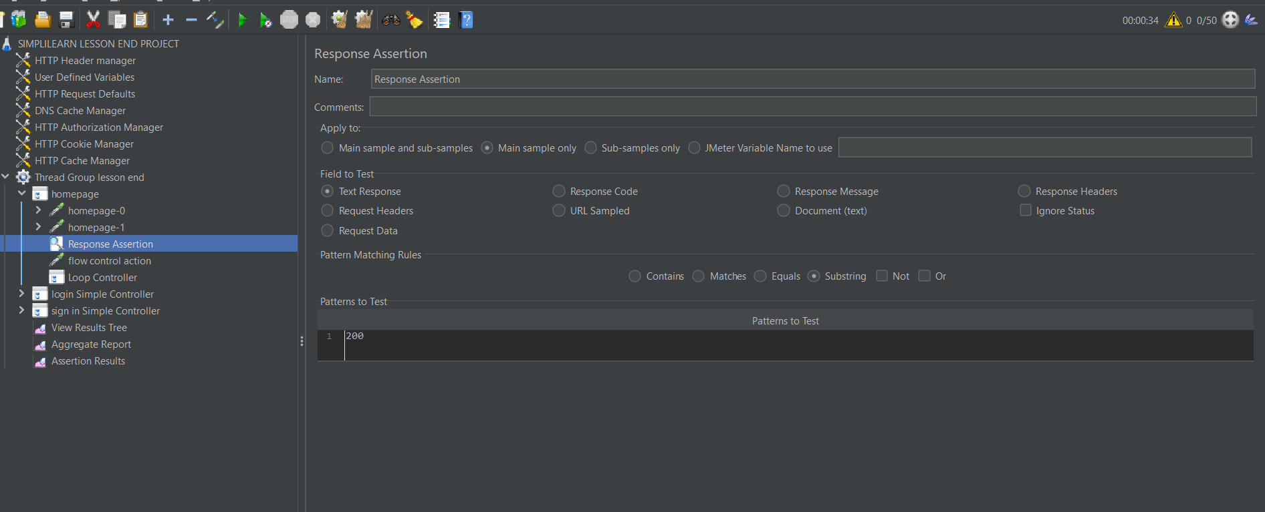

Adding flow control action to the homepage simple controller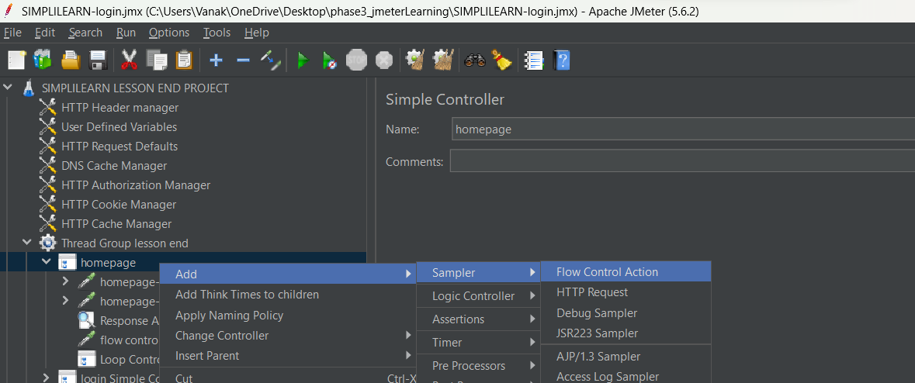

In flow control action,I gave duration (in milli. Seconds)=500

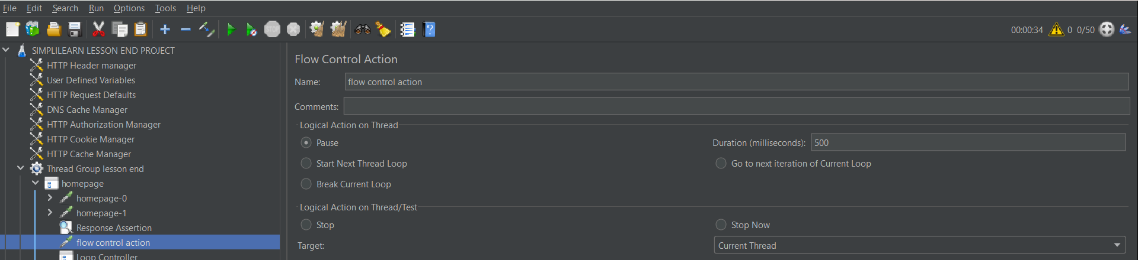

Adding Another controller to the home page controller that is loop controller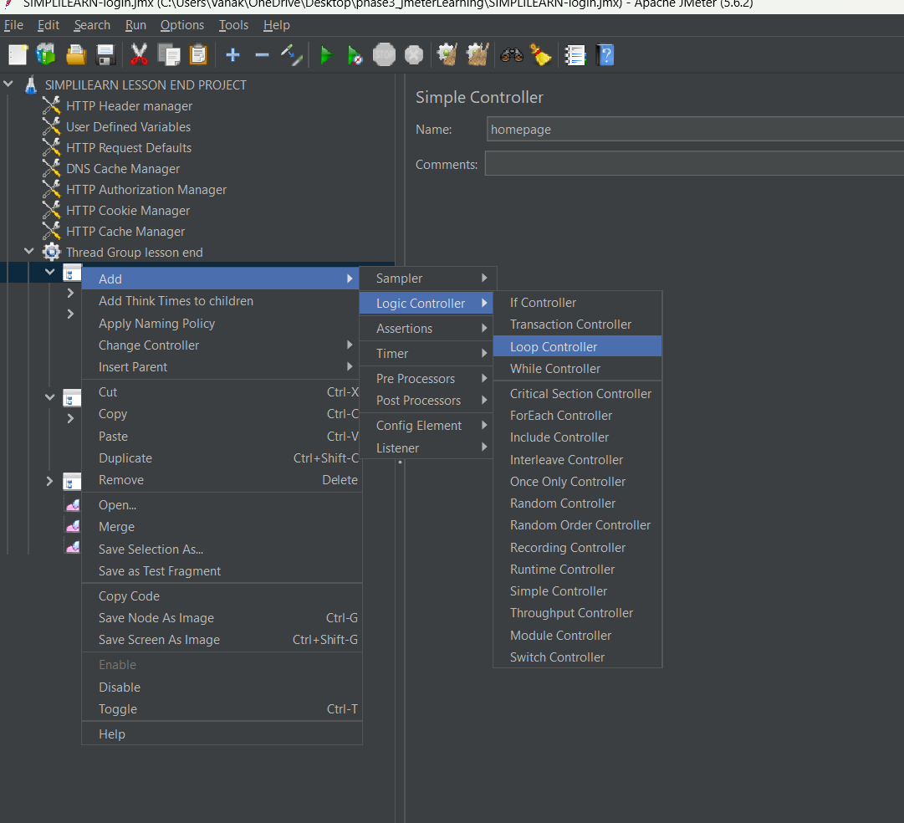

Giving loop count =2 in loop controller therefore homepage simple controller execute 2 times.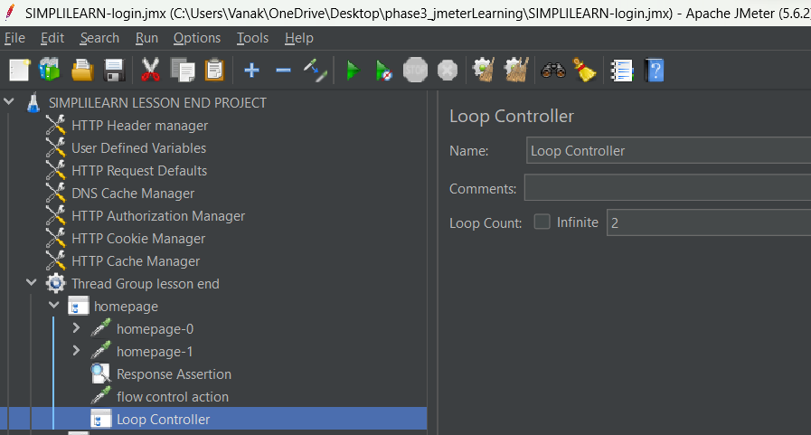

Now adding assertion to another simple controller (login-simple controller)

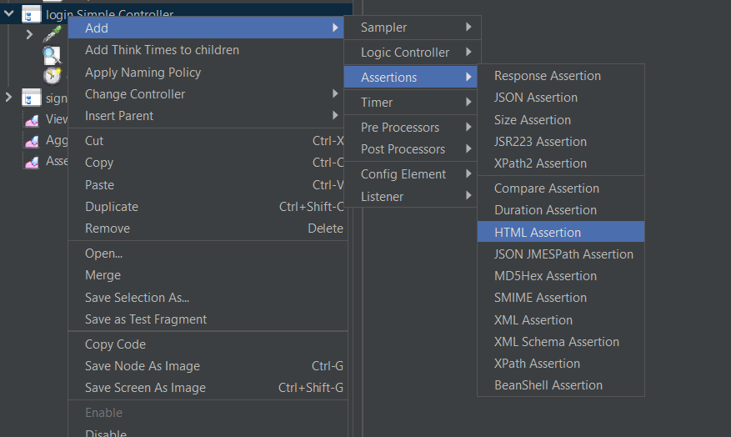

In html assertion ,by click on the browser and created a file name as simplilearn.txt ,to fetch the html warning from the browser while running.

And error threshold =0

Warning threshold =0

So we are expecting 0 warning and 0 error ,suppose If we get any error or warning then it will save in simplilearn.txt

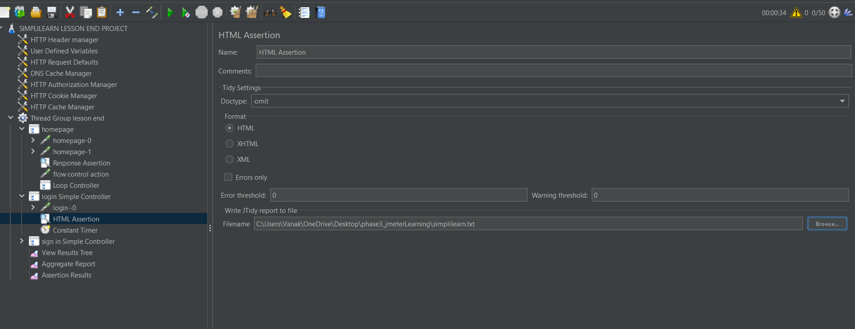

Adding constant timer to the login simple controller.

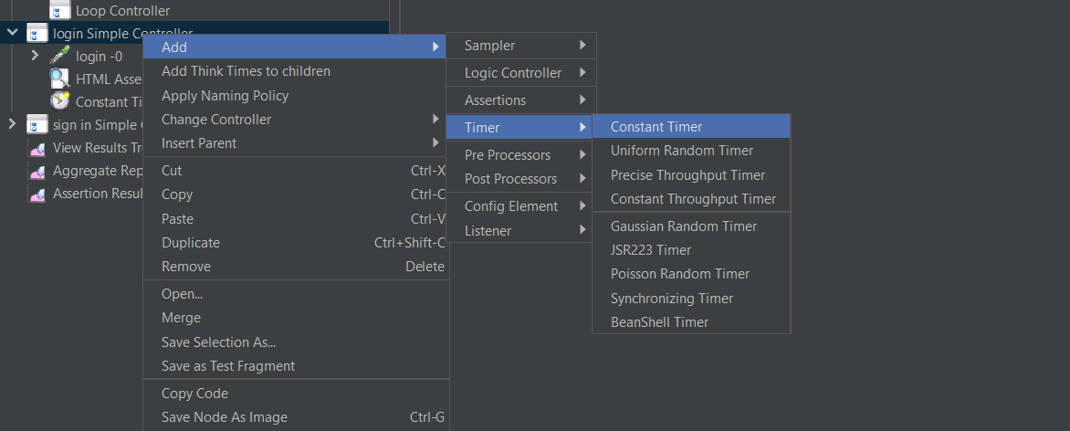

In constant timer gave thread (delay in milli. Seconds)=300

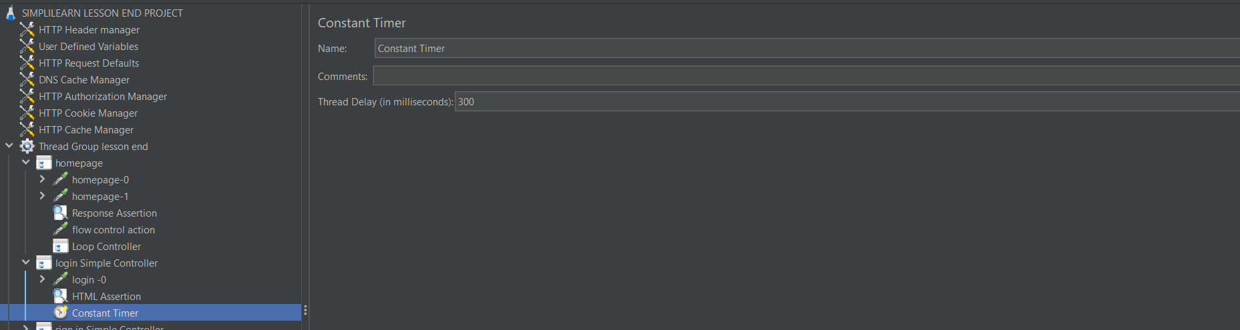

Adding duration assertion In sign in simple controller (3rd simple controller in thread group)

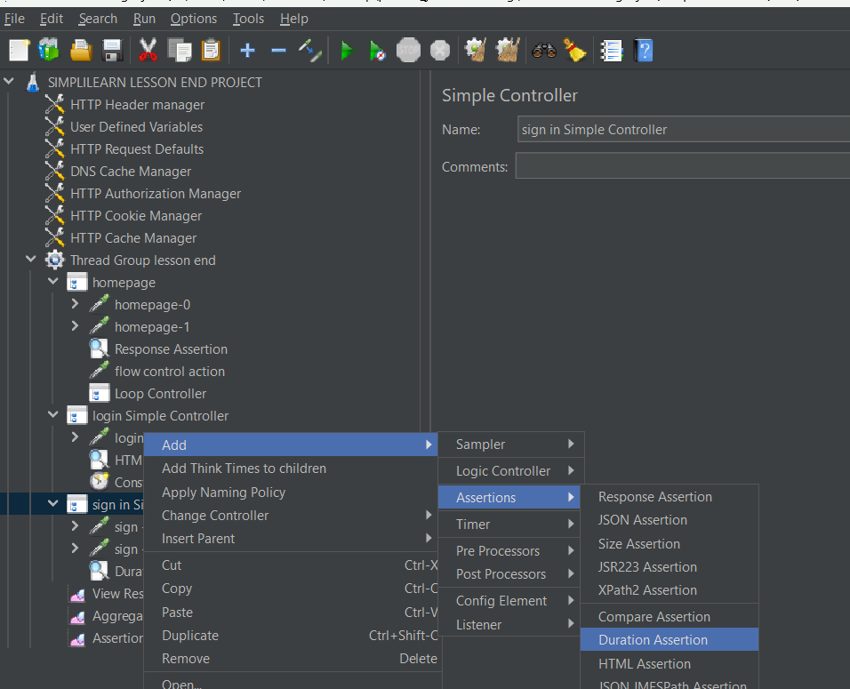

In duration assertion,

In duration in millisecond=5000

So, the simple control should completely execute in 5000 milliseconds otherwise it will fail

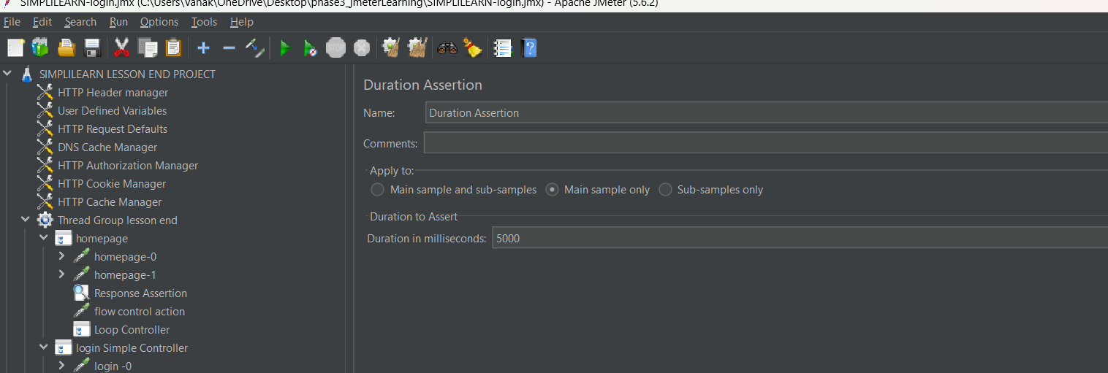

Adding listener to the thread group to view the result, so we added view result tree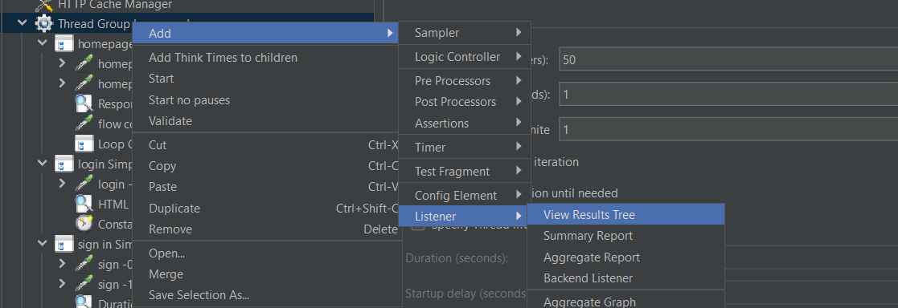

Adding the aggregate report to the thread group, for better viewing of time.

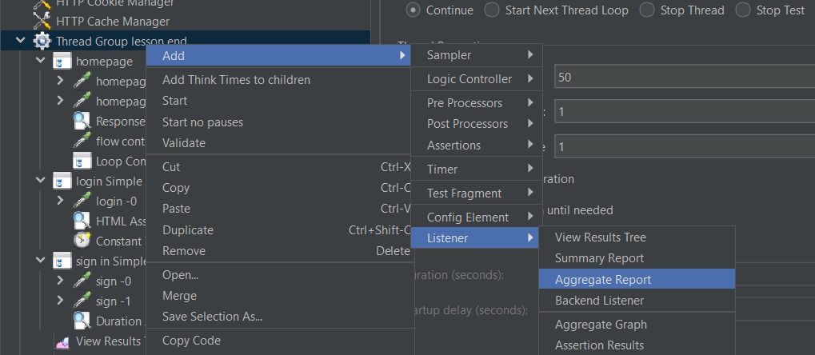

Adding assertion results to the listener to the thread group for to view the assertion output.

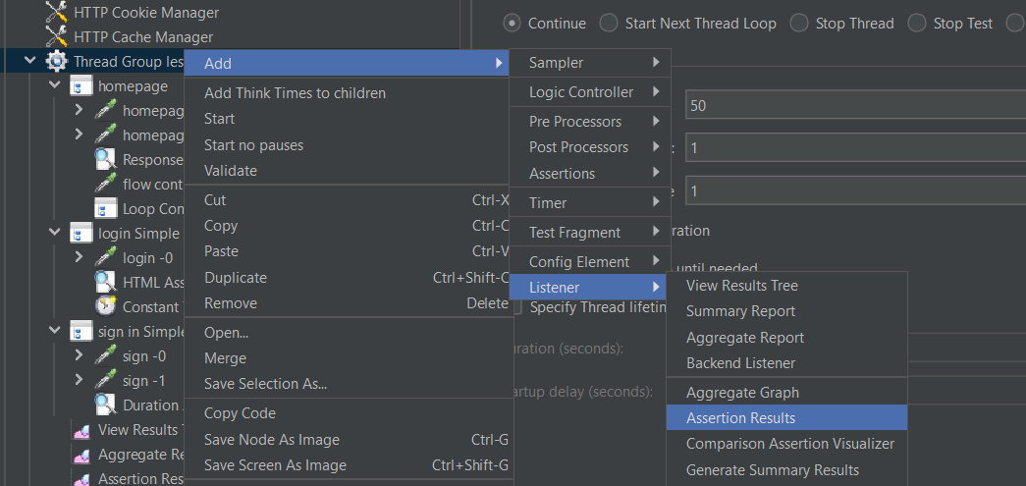

In thread group I gave , number of thread user =50

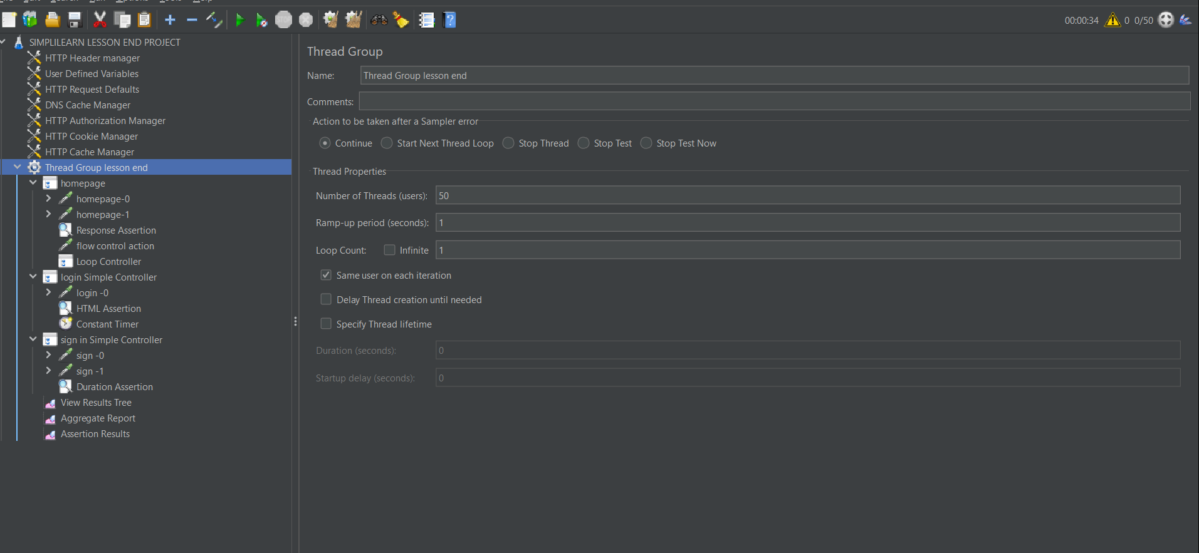

Then click on the run button .

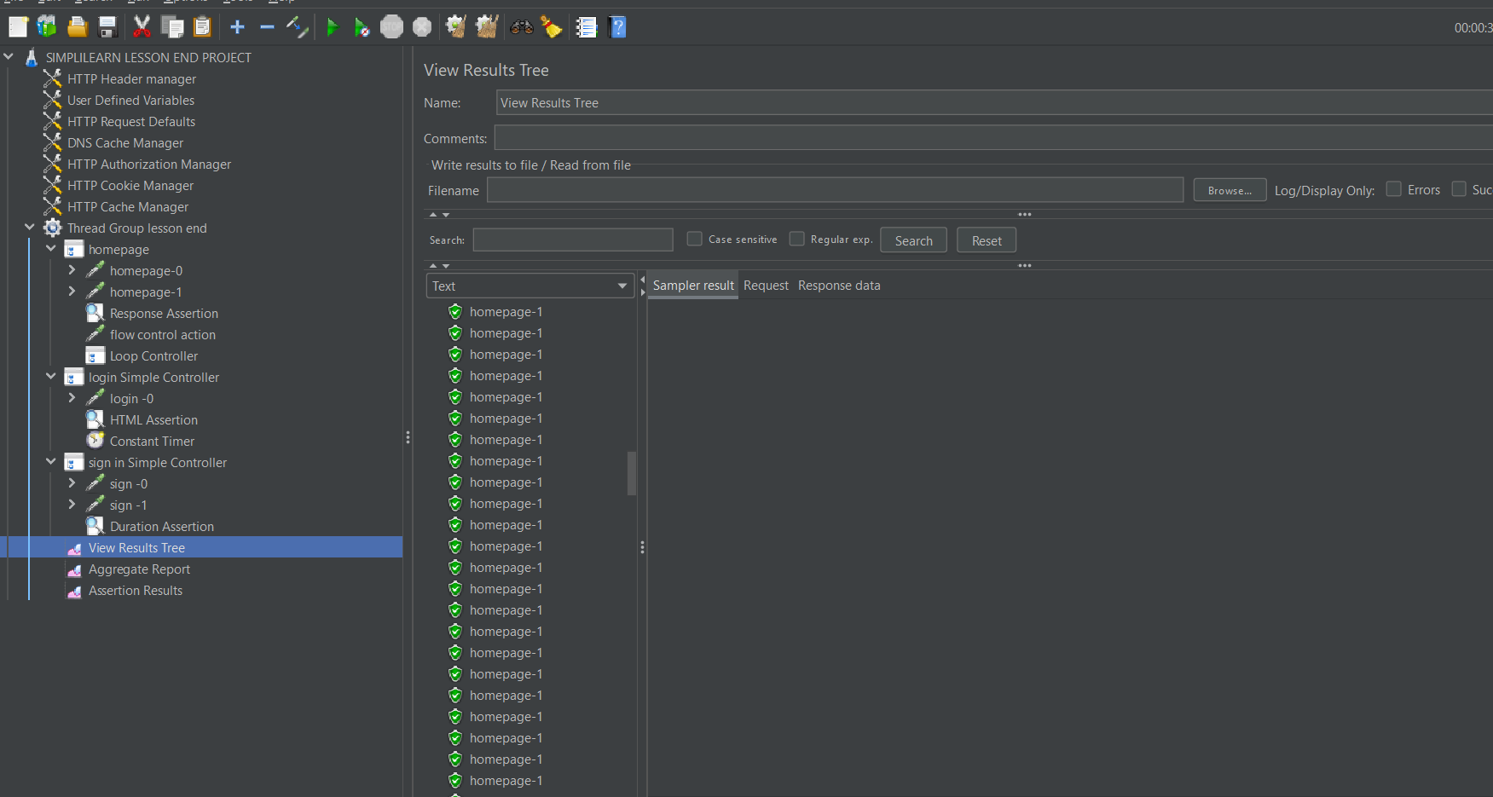

Login-0 result is failed because in html asseration,we expected 0 error and 0 warning ,but we got

Error -04

Warning -214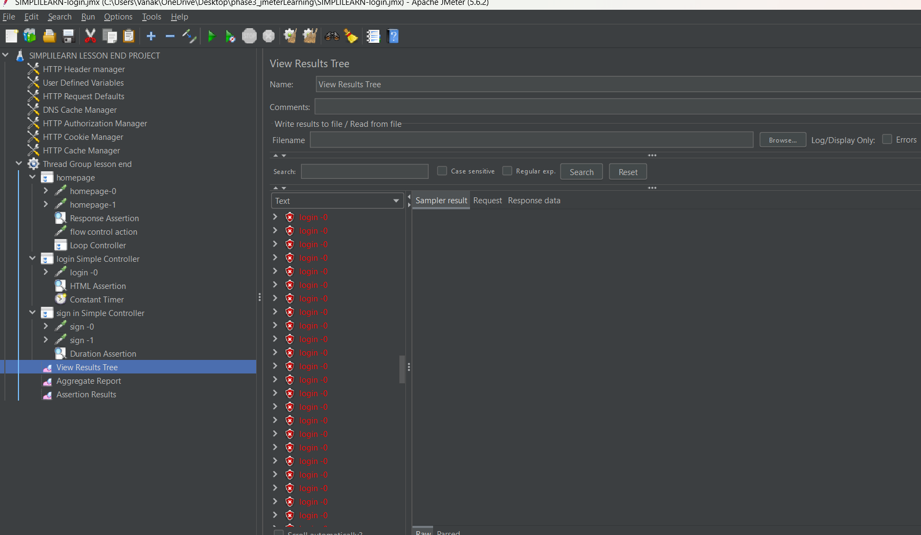

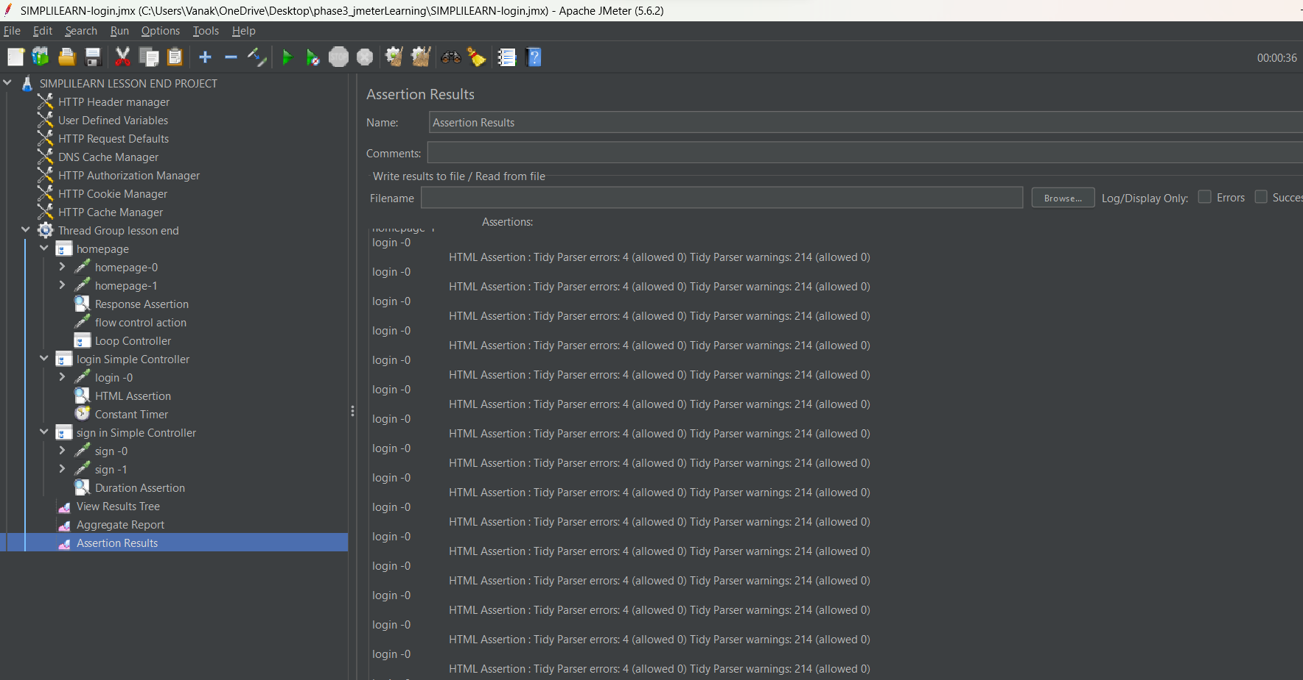

Signin-1 sample failed because we gave duration assertion =5000,but it extend more then 5000 milliseconds 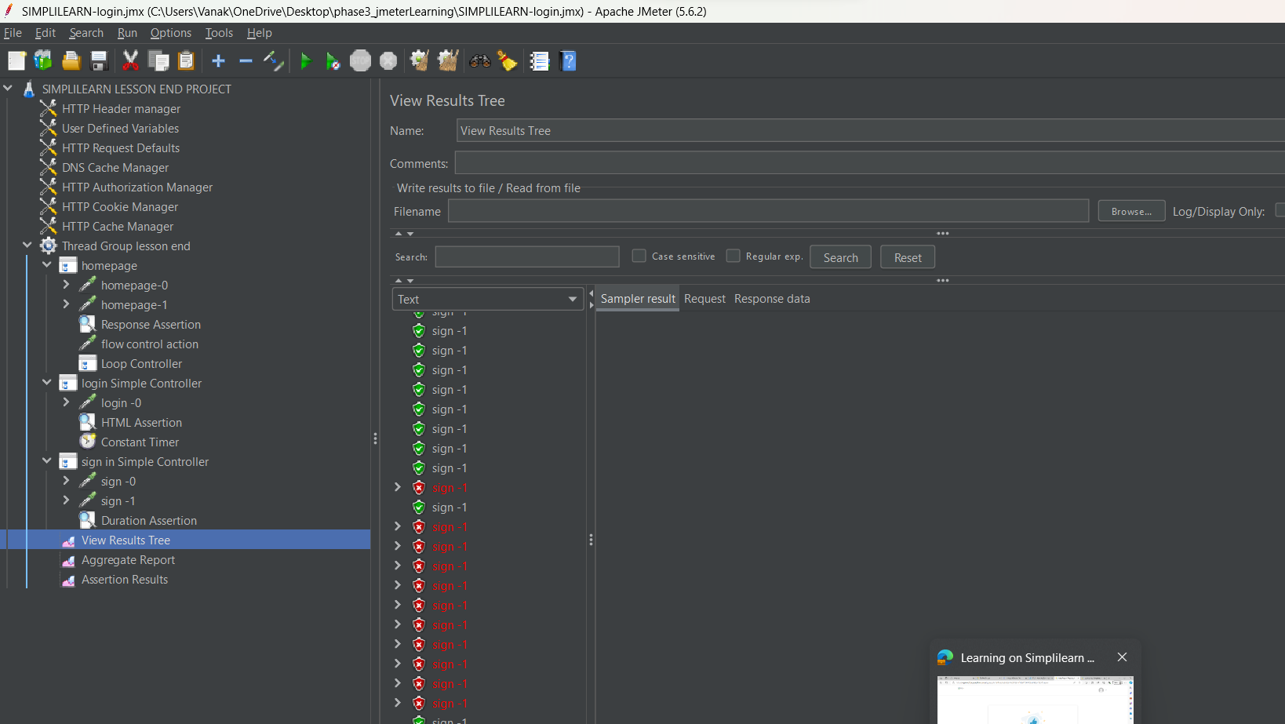

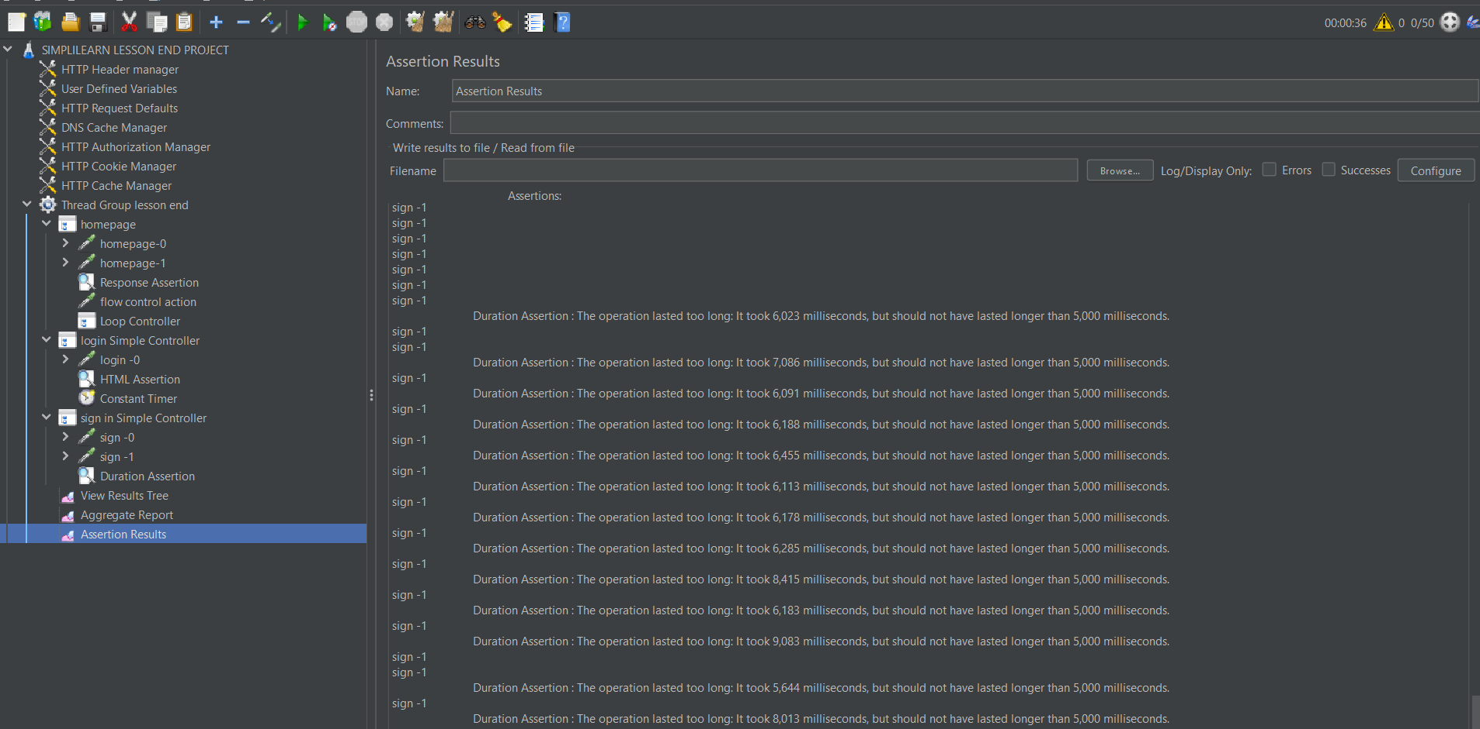

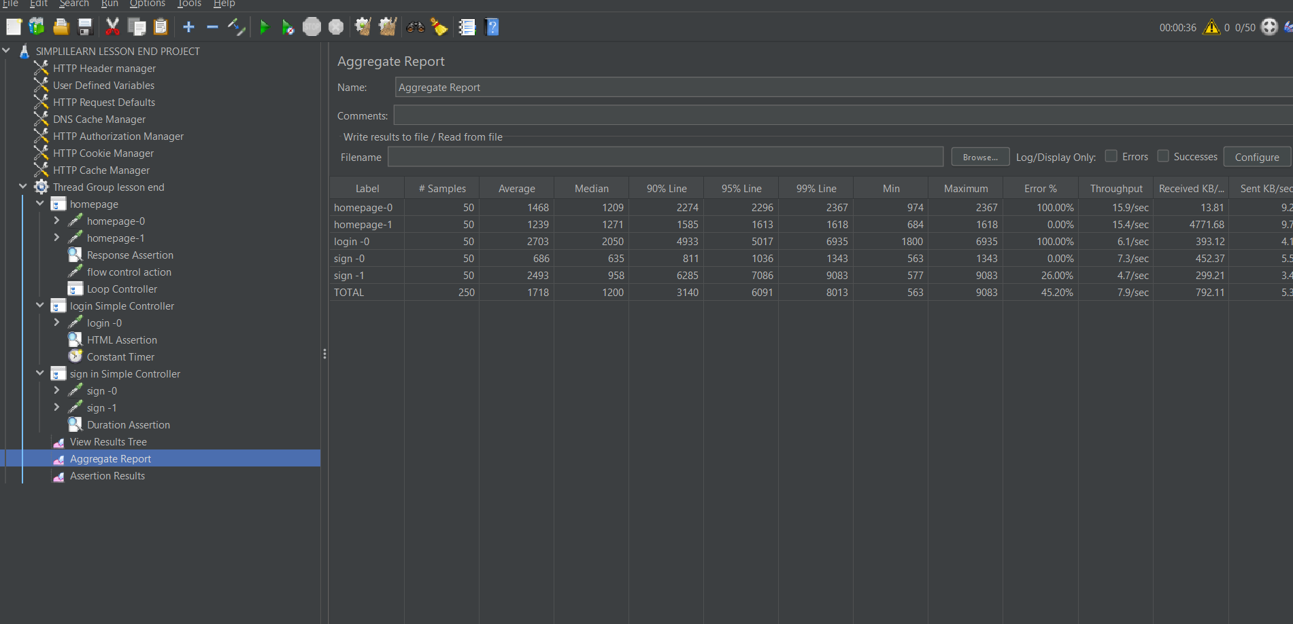

This are the Error and warning are saved in simplilearn.txt file are from html assertions.

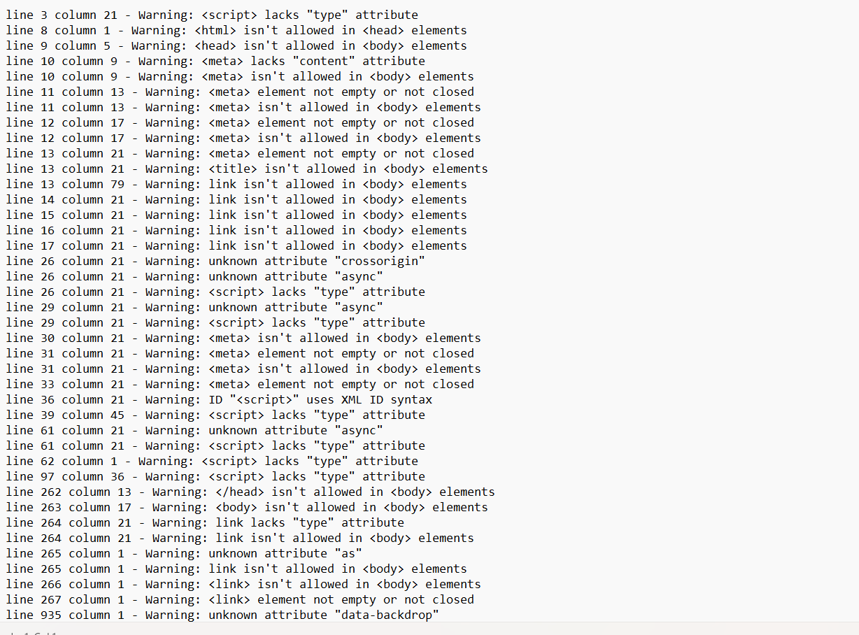

Validating Xpath-